Software Requirements Specification

for

MedSync Clinic Appointment and Treatment Management System

**Version 1.0 approved**

**Prepared by Group 06**

**August 06, 2025**

**Table of Contents**

**Table of Contents 2**

**Revision History 3**

**1. Introduction 4**

1.1 Purpose 4

1.2 Document Conventions 4

1.3 Intended Audience and Reading Suggestions 4

1.4 Product Scope 4

1.5 References 5

**2. Overall Description 6**

2.1 Product Perspective 6

2.2 Product Functions 7

2.3 User Classes and Characteristics 8

2.4 Operating Environment 9

2.5 Design and Implementation Constraints 9

2.6 User Documentation 10

2.7 Assumptions and Dependencies 11

**3. External Interface Requirements 12**

3.1 User Interfaces 12

3.2 Hardware Interfaces 13

3.3 Software Interfaces 13

3.4 Communications Interfaces 14

**4. System Features 15**

4.1 User Management 15

4.2 Flight Management 16

4.3 Booking and Ticketing 17

4.4 Itinerary Management 18

4.5 Airport and Location Information 19

**5. Other Nonfunctional Requirements 20**

5.1 Performance Requirements 20

5.2 Safety Requirements 20

5.3 Security Requirements 21

5.4 Software Quality Attributes 21

5.5 Business Rules 22

**6. Other Requirements 24**

6.1 Legal and Compliance Requirements 24

6.2 Internationalization and Localization 24

6.3 System Monitoring and Performance Optimization 24

**Appendix A: Glossary 25**

**Appendix B: Analysis Models 26**

**Appendix C: To Be Determined List 27**

**Appendix D: Team members 28**

**Revision History**

| **Name** | **Date** | **Reason For Changes** | **Version** |
| --- | --- | --- | --- |
|  |  |  |  |
|  |  |  |  |

**1. Introduction**

**1.1 Purpose**

*Healthcare management systems have become essential for modern medical facilities to provide efficient patient care and streamline operations. Traditional paper-based and Excel sheet systems are no longer adequate for managing the complex workflows of multi-specialty clinics.*

*MedSync, a medium-scale multi-specialty clinic with branches in Colombo, Kandy, and Galle, requires a comprehensive digital solution to manage their growing patient base and expanding services across multiple specialties.*

*This document describes the MedSync Clinic Appointment and Treatment Management System (CATMS), outlining its functionality, features, and requirements. This document serves as a guide for development and testing teams, with primary focus on database design and core functionality to ensure ACID properties and data integrity.*

**1.2 Document Conventions**

*This document is related to a database for the B Airways airline reservation system. This document is under the IEEE Software Requirement Specification. Using IEEE standard document rules as Font and text styles, use of table and figures, change history, formatting and page layout and review and approval.*

**1.3 Intended Audience and Reading Suggestions**

*This SRS document is intended for various stakeholders involved in the development and evaluation of the software system. The following are the primary types of readers for this document*

1. *Developers*
2. *Project Managers*
3. *Quality Assurance Testers*
4. *Healthcare Staff*
5. *Documentation Writers*

*Developers and project Managers can go through product scope, Detailed requirement and product functions in order to get a better understanding.*

**1.4 Product Scope**

*The MedSync Clinic Appointment and Treatment Management System (CATMS) is a comprehensive software solution designed to digitize and streamline clinic operations across multiple branches. This system will serve as the central platform for managing patient records, appointment scheduling, treatment documentation, billing, and insurance processing. The primary objectives of this system are*

1. *Benefits*
   1. ***Operational Efficiency****: Streamline appointment scheduling, treatment recording, and billing processes*
   2. ***Enhanced Patient Experience****: Provide seamless service across all branches with accessible patient records*
   3. ***Cross-Branch Integration****: Enable patient record accessibility and staff coordination across locations*
   4. ***Automated Billing****: Reduce manual errors and expedite invoice generation*
   5. ***Insurance Integration****: Streamline insurance claim processing and reimbursement tracking*
   6. ***Emergency Support****: Handle walk-in appointments and urgent care scenarios*
2. *Objectives and goals*
   1. *Enable MedSync to operate efficiently across Colombo, Kandy, and Galle branches*
   2. *Automate appointment scheduling with conflict prevention and rescheduling capabilities*
   3. *Implement comprehensive patient record management with cross-branch accessibility*
   4. *Create a dynamic treatment catalogue with pricing and service code management*
   5. *Establish an automated billing system with partial payment tracking and outstanding balance management*
   6. *Integrate insurance claim processing with reimbursement calculations*
   7. *Generate management reports for operational insights and decision-making*
   8. *Ensure ACID properties through database triggers, procedures, and constraints.*

**1.5 References**

1. *[1] IEEE Computer Society, "IEEE Std 830-1998: IEEE Recommended Practice for Software Requirements Specifications," Institute of Electrical and Electronics Engineers, New York, NY, USA, 1998.*
2. *[2] Blaze Technology Solutions, "How to Build a Database: Healthcare Database Design Standards," Blaze.tech, 2023. [Online]. Available:* [*https://www.blaze.tech/post/how-to-build-a-database*](https://www.blaze.tech/post/how-to-build-a-database)*. [Accessed Sept. 10, 2023].*
3. *[3] Ministry of Health, Sri Lanka, "E-Health Guidelines for Sri Lanka: Version 1.0," Ministry of Health, Colombo, Sri Lanka, Tech. Rep., Sept. 2022. [Online]. Available:* [*https://www.health.gov.lk/wp-content/uploads/2022/09/x9_E-Health-Guidelines-1.pdf*](https://www.health.gov.lk/wp-content/uploads/2022/09/x9_E-Health-Guidelines-1.pdf)*. [Accessed Sept. 10, 2023].*
4. *[4] Ministry of Health, Sri Lanka, "Information Security Guidelines for Healthcare Systems: Version 1.0," Ministry of Health, Colombo, Sri Lanka, Tech. Rep., Nov. 2023. [Online]. Available:* [*https://www.health.gov.lk/wp-content/uploads/2023/11/Information-security-gudeline_1.0-2.3.23.pdf*](https://www.health.gov.lk/wp-content/uploads/2023/11/Information-security-gudeline_1.0-2.3.23.pdf)*. [Accessed Sept. 10, 2023].*
5. *[5] Oracle Corporation, "MySQL 8.0 Reference Manual: Healthcare Applications Guide," Oracle Corp., Redwood City, CA, USA, 2023. [Online]. Available:* [*https://dev.mysql.com/doc/refman/8.0/en/*](https://dev.mysql.com/doc/refman/8.0/en/)*. [Accessed Sept. 10, 2023].*
6. *[7] World Health Organization, "Health Level Seven International (HL7) FHIR R4 Implementation Guide," World Health Organization, Geneva, Switzerland, 2019. [Online]. Available:* [*https://www.hl7.org/fhir/R4/*](https://www.hl7.org/fhir/R4/)*. [Accessed Sept. 10, 2023].*

**2. Overall Description**

**2.1 Product Perspective**

*The MedSync CATMS operates as a centralized database system serving three clinic branches with the following characteristics:*

**2.1.1 Context:**

* *The system replaces existing paper-based records and Excel spreadsheet management with a fully integrated digital solution*
* *This system is designed to support MedSync's expansion and improved service delivery across multiple specialties and locations*
* *It serves as a critical component of MedSync's digital transformation and operational efficiency strategy*

**2.1.2 Origin:**

* *Current manual systems are inadequate for managing complex workflows and cross-branch operations*
* *The system addresses operational challenges including appointment conflicts, billing errors, and data accessibility issues*
* *The need for this system arose from MedSync's growth in patient volume and expansion to multiple specialties*

**2.1.3 Relationship to Larger System:**

* *The CATMS is the core operational system for MedSync's healthcare delivery*
* *While this SRS focuses on database design and core functionality, the system interfaces with external components including payment gateways and insurance systems*
* *The system integrates with potential future modules such as pharmacy management and laboratory information systems*

**2.1.4 Major Components and Interfaces:**

* ***Patient Management Interface****: For patient registration and record management*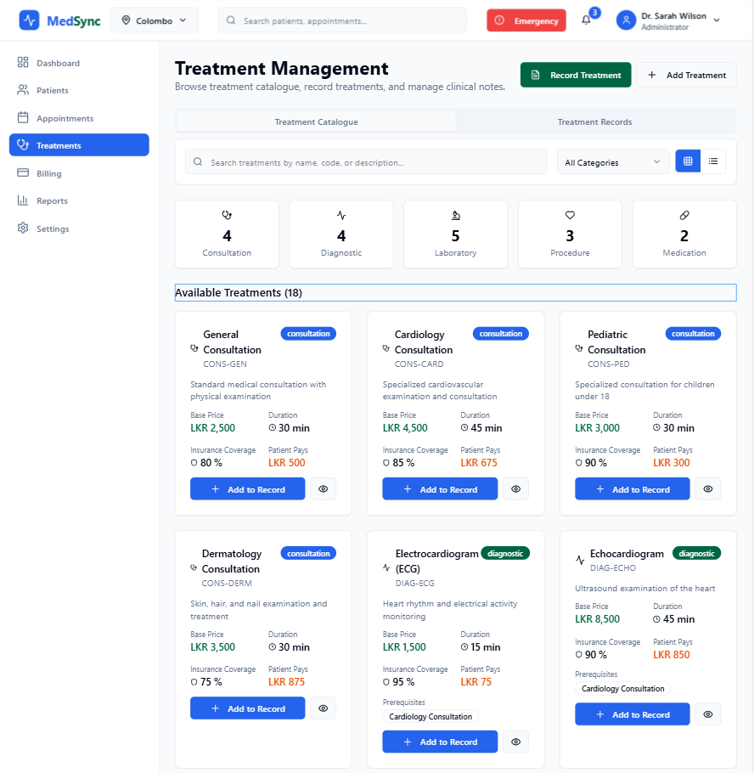
* ***Staff Interface****: For doctors, nurses, and administrative staff*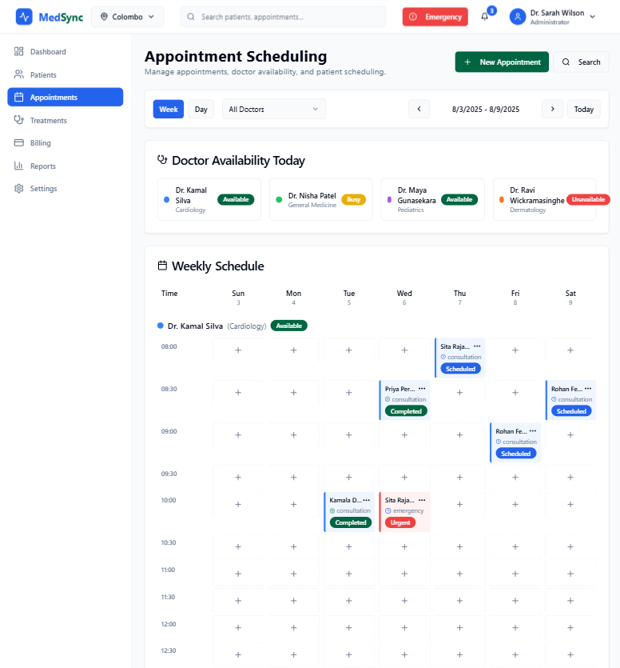

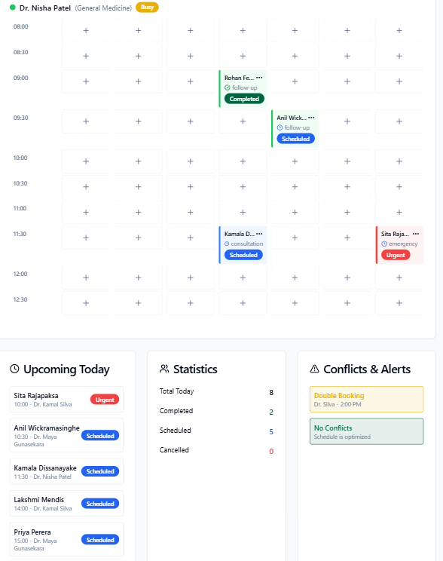

* ***Billing Interface****: For financial transactions and insurance processing*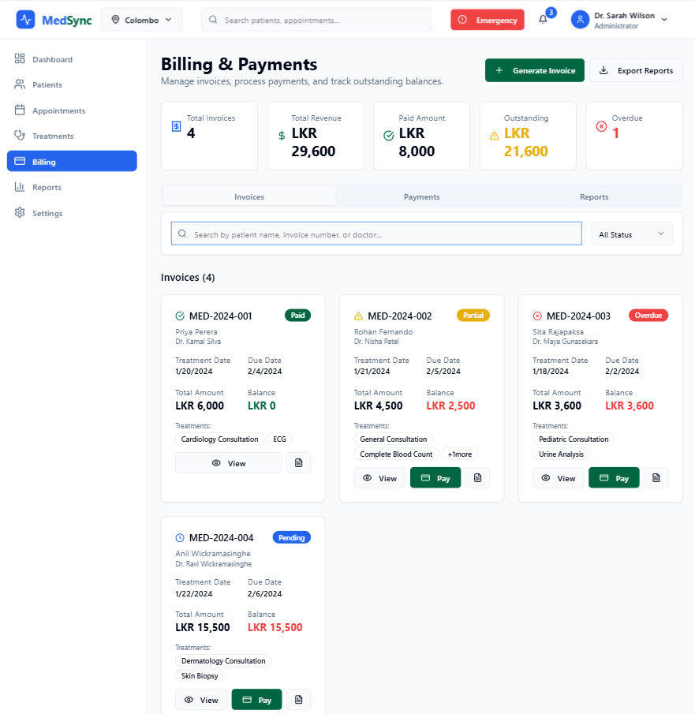
* ***Reporting Interface****: For management dashboards and analytics*

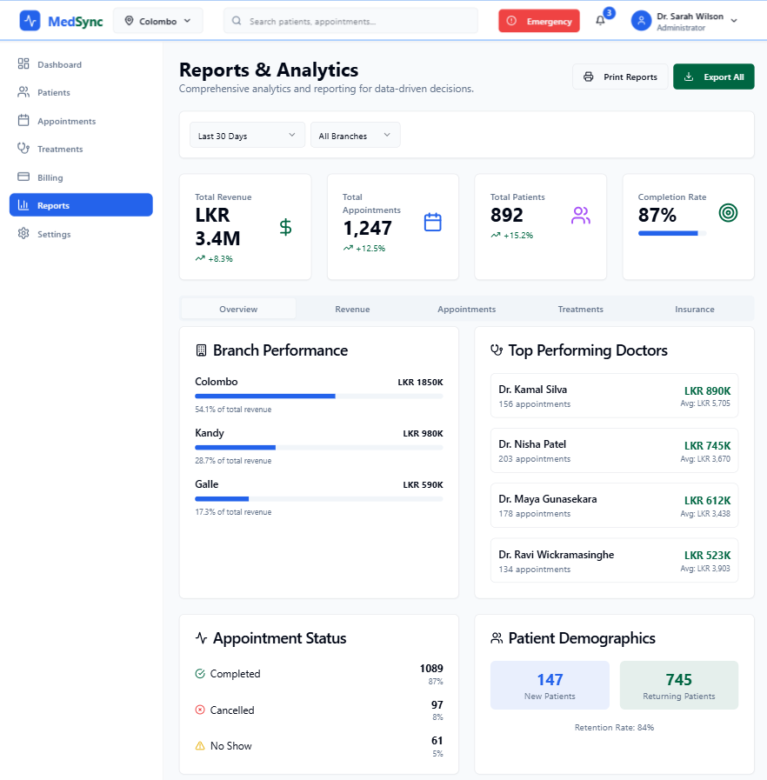

* ***External Interfaces****: Insurance companies, payment processors, and regulatory reporting systems*

**2.1.5 Diagram:**

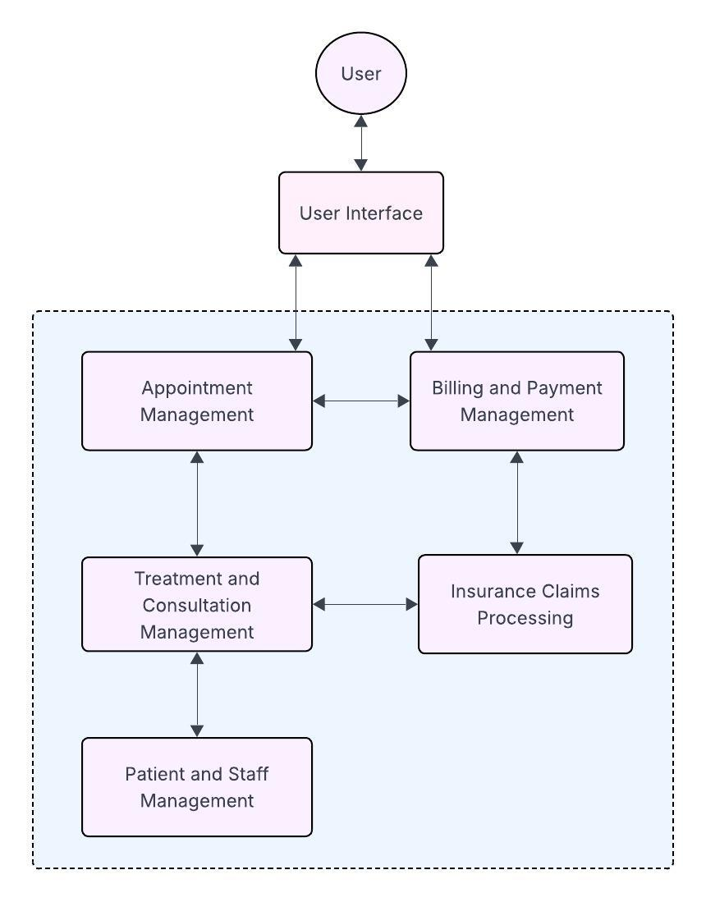

**2.2 Product Functions**

#### 2.2.1 Patient Management

* ***Patient Registration****: Register new patients with comprehensive demographic and medical information*
* ***Cross-Branch Access****: Enable patient record accessibility across all MedSync branches*
* ***Insurance Integration****: Manage patient insurance information and policy details*
* ***Emergency Contact Management****: Maintain updated emergency contact information*

#### 2.2.2 Appointment Scheduling

* ***Conflict-Free Scheduling****: Prevent overlapping appointments for doctors using database constraints*
* ***Multi-Status Tracking****: Manage appointments through Scheduled, Completed, and Cancelled states*
* ***Rescheduling Support****: Enable appointment modifications with history tracking*
* ***Emergency Walk-ins****: Support immediate appointment creation for urgent cases*

#### 2.2.3 Treatment Management

* ***Treatment Catalogue****: Maintain a comprehensive list of available treatments with pricing*
* ***Treatment Recording****: Document treatments provided during completed appointments*
* ***Service Code Management****: Assign and track service codes for billing and reporting*
* ***Consultation Notes****: Record detailed consultation and treatment notes*

#### 2.2.4 Billing and Financial Management

* ***Automated Invoice Generation****: Create bills based on completed treatments and consultations*
* ***Partial Payment Tracking****: Handle full and partial payments with outstanding balance management*
* ***Insurance Claims Processing****: Submit and track insurance claims for eligible treatments*
* ***Financial Reporting****: Generate revenue reports and outstanding balance summaries*

#### 2.2.5 Reporting and Analytics

1. ***Branch-wise appointment summary per day*** *(scheduled, completed, cancelled)*
2. ***Doctor-wise revenue report*** *with performance metrics*
3. ***List of patients with outstanding balances*** *for collection follow-up*
4. ***Number of treatments per category*** *over specified periods*
5. ***Insurance coverage vs. out-of-pocket payments*** *analysis*

**2.3 User Classes and Characteristics**

**2.3.1 Administrative Staff**

* ***Receptionist/Front Desk:*** *Patient registration, appointment scheduling, basic billing*
* ***Branch Manager:*** *Local operations oversight, staff management, local reporting*
* ***Billing Administrator:*** *Financial management, insurance processing, payment tracking*
* ***System Administrator:*** *User management, system configuration, data backup*

#### 2.3.2 Medical Staff

* ***Doctors:*** *Patient consultation, treatment prescription, appointment management, clinical notes*
* ***Nurses:*** *Patient care support, treatment assistance, basic data entry*
* ***Specialists:*** *Specialized consultation, advanced treatment procedures*

#### 2.3.3 Patients

* ***Registered Patients:*** *Individuals with complete records in the system*
* ***Walk-in Patients:*** *Emergency or urgent care patients without prior appointments*
* ***Insured Patients:*** *Patients with active insurance coverage requiring claim processing*

#### 2.3.4 Management

* ***Executive Management:*** *Strategic oversight, performance analysis, financial reporting*
* ***Clinical Director:*** *Medical operations oversight, quality assurance, staff performance*

**2.4 Operating Environment**

**2.4.1 Technical Environment**

* ***Database System:*** *MySQL for reliable data storage and retrieval*
* ***Web Servers:*** *Standard web servers supporting Node.js applications*
* ***Network Infrastructure:*** *Secure network connections between branches and central database*
* ***Client Access:*** *Web-based interface accessible through standard browsers*

#### 2.4.2 Physical Environment

* ***Multi-Branch Setup:*** *Three primary locations (Colombo, Kandy, Galle)*
* ***Hardware Requirements:*** *Standard computers, printers, network equipment*
* ***Connectivity:*** *Reliable internet connection for real-time data synchronization*

**2.5 Design and Implementation Constraints**

**2.5.1 Healthcare Compliance**

* ***HIPAA Equivalent:*** *Comply with Sri Lankan healthcare data privacy regulations*
* ***Medical Records Standards:*** *Maintain proper medical record keeping standards*
* ***Audit Trail Requirements:*** *Implement comprehensive logging for compliance*

#### 

#### 

#### 2.5.2 Database Constraints

* ***Referential Integrity:*** *Implement foreign key constraints to maintain data consistency*
* ***Concurrent Access:*** *Handle multiple users accessing the same records simultaneously*
* ***Backup and Recovery:*** *Regular automated backups with disaster recovery procedures*

#### 2.5.3 Performance Constraints

* ***Response Time:*** *Database queries should respond within 2 seconds for standard operations*
* ***Concurrent Users:*** *Support minimum 50 concurrent users across all branches*
* ***Data Volume:*** *Handle growth to 10,000+ patients and 100,000+ appointments annually*

#### 2.5.4 Security Constraints

* ***Data Encryption:*** *Encrypt sensitive patient and financial data*
* ***Access Control:*** *Role-based access control with user authentication*
* ***Network Security:*** *Secure data transmission between branches and database*

#### 2.5.5 Integration Constraints

* ***Insurance Systems:*** *Interface with major Sri Lankan insurance providers*
* ***Payment Systems:*** *Integrate with local and international payment processors*
* ***Regulatory Reporting:*** *Generate reports required by health authorities*

**2.6 User Documentation**

*User documentation will include user manuals and online help resources.*

#### 2.6.1 User Manuals

* ***Comprehensive Digital Manuals:*** *Provided in PDF format covering all system functions*
* ***Role-Specific Guides:*** *Separate manuals for different user types (doctors, administrative staff, management)*
* ***Step-by-Step Instructions:*** *Detailed procedures with screenshots for common tasks*
* ***Troubleshooting Guides:*** *Common issues and resolution procedures*

**2.7 Assumptions and Dependencies**

**2.7.1 Assumptions:**

1. ***Internet Connectivity****: Reliable internet connection available at all branch locations*
2. ***Staff Computer Literacy****: Basic computer skills among all system users*
3. ***Hardware Availability****: Standard computer hardware available at each branch*
4. ***Regulatory Stability****: Healthcare regulations remain stable during development period*
5. ***Insurance Cooperation****: Insurance companies willing to integrate with the system*
6. ***Data Migration****: Existing patient records can be successfully migrated to new system*

**2.7.2 Dependencies:**

1. ***Database Server****: Reliable database server infrastructure with proper maintenance*
2. ***Network Infrastructure****: Stable network connectivity between branches*
3. ***Third-Party Integrations****: Availability of insurance and payment gateway APIs*
4. ***Regulatory Approvals****: Compliance certifications from relevant healthcare authorities*
5. ***Staff Training****: Adequate training time and resources for system adoption*
6. ***Data Backup Services****: Reliable backup and disaster recovery services*

**3. External Interface Requirements**

**3.1 User Interfaces**

*The MedSync CATMS will provide role-based interfaces for different user types, ensuring optimal workflow efficiency and data security.*

***Logical Characteristics***

* *GUI Standards*
  + *Clean, medical-appropriate color scheme with high contrast for readability*
  + *Consistent navigation structure across all modules*
  + *Responsive design supporting desktop, tablet, and mobile access*
  + *Accessibility compliance for users with disabilities*
  + *MedSync branding integration throughout the interface*
* *Screen Layout Constraints*
  + *Modular layout with collapsible sections for different screen sizes*
  + *Priority-based information hierarchy with critical data prominently displayed*
  + *Consistent header with user information, branch selection, and quick actions*
  + *Tabbed interface for different functional areas (Appointments, Patients, Billing)*
  + *Real-time status indicators for appointments and system health*
  + *The layout will be used consistently throughout every page to provide users with a seamless experience.*
* *Standard Interface Elements* 
  + *Universal search functionality for patients, appointments, and treatments*
  + *Quick action buttons for common tasks (New Appointment, Patient Search, Emergency)*
  + *Standardized forms with validation and auto-complete features*
  + *Consistent error message display with clear resolution guidance*
  + *Help integration with context-sensitive assistance*

***Software Components***

***Patient Management Interface***

* *Patient registration form with validation for required fields*
* *Patient search with multiple criteria (name, ID, phone, insurance)*
* *Patient profile view with tabbed sections (Personal, Medical, Insurance, History)*
* *Emergency contact management with relationship tracking*

***Appointment Scheduling Interface***

* *Calendar view with doctor availability and appointment status*
* *Drag-and-drop rescheduling with conflict detection*
* *Time slot management with configurable intervals*
* *Appointment details form with patient, doctor, and treatment information*
* *Emergency walk-in registration with priority handling*

***Treatment and Clinical Interface***

* *Treatment catalogue browser with search and categorization*
* *Treatment prescription interface with dosage and instruction fields*
* *Clinical notes editor with templates and structured data entry*
* *Treatment history view with chronological organization*

***Billing and Payment Interface***

* *Automated invoice generation with itemized treatment costs*
* *Payment processing with multiple payment method support*
* *Insurance claim submission with status tracking*
* *Outstanding balance management with payment history*

***Reporting and Analytics Interface***

* *Dashboard with key performance indicators and branch metrics*
* *Report generation interface with customizable parameters*
* *Data visualization with charts and graphs*
* *Export functionality for reports in multiple formats (PDF, Excel, CSV)*

*To comply with IEEE standards, the user interface of the MedSync Clinic Appointment and Treatment Management System must be tested for usability, accessibility, and compatibility across different devices and operating systems. The tests should verify that the standard buttons and functions work correctly, that error messages are consistent and clear, and that the user interface is responsive. The user interface specification should also be documented to provide a clear and concise description of the design and functionality of the interface.*

**3.2 Hardware Interfaces**

*The MedSync CATMS database and DBMS require various hardware interfaces to function properly within the healthcare environment. The following specifications define the logical and physical characteristics of required hardware interfaces.*

#### 3.2.1 Supported Platforms

* ***Desktop Systems****: Windows 10/11, macOS 10.15+, Ubuntu 18.04+*
* ***Mobile Devices****: iOS 12+, Android 8.0+ for basic functionality*
* ***Tablets****: iPad OS 13+, Android tablets for portable access*
* ***Network Infrastructure****: Ethernet and Wi-Fi connectivity support*

#### 3.2.2 Data Interactions

* ***File Management****: Document storage for medical records and insurance documents*
* ***Backup Operations****: Automated daily backups with incremental updates*
* ***Print Services****: Integration with network printers for reports and receipts*

#### 3.2.3 Communication Protocols

* ***Database Connectivity****: Secure MySQL connections with SSL encryption*
* ***Web Communications****: HTTPS for all client-server communications*
* ***File Transfer****: SFTP for secure document exchange with insurance providers*
* ***API Communications****: RESTful APIs with JSON for external system integration*

*To comply with IEEE standards, the software and hardware components of the Database Management System software must be tested for compatibility, functionality, and performance. The tests should verify that the communication protocols are working properly, that the user interface is responsive, and that the data interactions between the software and hardware components are accurate and secure.*

**3.3 Software Interfaces**

*The system will be interfacing with various software elements to ensure a continuous and uninterrupted workflow during operations. Following are the connections and characteristics that define the interfaces between the system and other software components. The system is the database and the DBMS.*

#### 33.3.1 Database Management System

#### *Primary Database: MySQL for main data storage*

#### *Connection Pooling: Efficient database connection management for concurrent users*

#### *Transaction Management: ACID-compliant transaction handling with rollback capabilities*

#### *Backup Integration: Automated backup software with point-in-time recovery*

#### 3.3.2 Operating System Integration

#### *Multi-Platform Support: Cross-platform compatibility for Windows, macOS, and Linux*

#### *Security Integration: Operating system authentication and security features*

#### *File System Access: Secure document storage with proper permissions*

#### *Network Services: Integration with local network services and domain authentication*

#### 3.3.3 External System Interfaces

#### *Insurance Provider APIs: Integration with major Sri Lankan insurance companies*

#### *Sri Lanka Insurance Corporation API*

#### *Union Assurance API*

#### *Ceylinco Insurance API*

#### *Payment Gateway Integration: Support for local and international payment processors*

#### *PayHere for local payments*

#### *Stripe/PayPal for international payments*

#### *Government Reporting Systems: Integration with Ministry of Health reporting requirements*

#### *Laboratory Information Systems: Future integration capability with lab systems*

#### *3.3.4 Shared Data Management*

#### *Patient Records: Synchronized across all branches with real-time updates*

#### *Treatment Catalogue: Centralized management with branch-specific pricing*

#### *Staff Schedules: Cross-branch visibility for resource planning*

#### *Financial Data: Consolidated billing and payment information*

### *3.4 Communications Interfaces*

#### *3.4.1 Network Communication*

* ***HTTP/HTTPS Protocols****: Secure web-based communication for all user interfaces*
* ***Database Protocols****: Native database protocols (MySQL, PostgreSQL) with encryption*
* ***REST APIs****: RESTful web services for external system integration*
* ***File Transfer Protocols****: SFTP/FTPS for secure document exchange*

#### *3.4.2 Security Protocols*

* ***SSL/TLS Encryption****: All network communications encrypted with TLS 1.3*
* ***API Authentication****: OAuth 2.0 or API key authentication for external services*
* ***Database Encryption****: Encrypted database connections and data-at-rest encryption*

#### *3.4.3 Message Formats*

* ***JSON****: Primary data exchange format for API communications*
* ***XML****: Support for legacy system integration where required*
* ***PDF/CSV****: Standard formats for reports and data export*

**4. System Features**

**4.1 Appointment Management**

***a. Overview and Priority***

* *This feature enables the scheduling, updating, cancellation, and completion of appointments between patients and doctors. The system ensures that doctors do not have overlapping appointments and supports both regular and emergency walk-in bookings. Appointments may be updated to reflect their current status: Scheduled, Completed, or Cancelled*

***b. Stimulus/Response Sequences***

| *User Stimulus* | *System Response* |
| --- | --- |
| *A User requests an appointment at a branch.* | *The system checks the availability of the selected doctor and creates an appointment if the slot is free.* |
| *A User requests to reschedule or cancel an existing appointment.* | *The system updates the appointment slot and notifies relevant parties* |
| *A doctor marks an appointment as Completed* | *The system prompts for treatment/consultation details and generates billing records accordingly.* |

***c. Functional Requirements***

*REQ-AM-1: The system shall allow patients to schedule appointments with a doctor at a specific branch and time slot.*

* *Collect the patient’s details and appoint them to a specific time slot.*

*REQ-AM-2: The system shall prevent scheduling of overlapping appointments for the same doctor.*

* *The system should not allow scheduling two appointments into the same time slot of a doctor*

*REQ-AM-3: The system shall allow patients or staff to cancel or reschedule appointments.*

*REQ-AM-4: The system shall maintain the status of each appointment as Scheduled, Completed, or Cancelled.*

**4.2 Patient Record Management**

**4.2.1 User Registration**

***a. Overview***

* *This feature allows clinic staff to register new patients into the system. During registration, personal details such as name, date of birth, gender, emergency contact, and health insurance information are collected and stored securely. This process ensures each patient has a unique, centralized profile accessible across all branches.*

***b. Stimulus/Response Sequences***

| *User Stimulus* | *System Response* |
| --- | --- |
| *The user clicks the Register new patient tab* | *Displays a registration forum.* |
| *The user attempts to register again using the same personal details.* | *The system detects existing record and prevents duplicate entry or notifies the user.* |

***c. Functional Requirements***

*REQ-UR-1: The system shall allow staff to register a new patient by entering personal details, emergency contacts, and insurance information*

*REQ-UR-2: he system shall assign a unique patient ID to each newly registered individual.*

*REQ-UR-3: he system shall validate input fields to ensure completeness and correctness of patient information.*

*REQ-UR-4: The system shall prevent the creation of duplicate patient profiles based on key identifiers (e.g., NIC/passport number or contact).*

**4.2.2 Patient Record Handling**

***a. Overview***

* *This feature allows authorized clinic staff to access and update existing patient records across all branches. Records include demographic details, emergency contacts, and insurance data. It supports data accuracy and continuity of care across locations.*

***b. Stimulus/Response Sequences***

| *User Stimulus* | *System Response* |
| --- | --- |
| *Staff accesses a returning patient's profile at a different branch.* | *System retrieves and displays the patient's complete record.* |
| *A patient updates their emergency contact or insurance policy..* | *System stores the updated data and reflects it in real-time across the system.* |

***c. Functional Requirements***

*REQ-FM-1: The system shall allow staff to search and retrieve a patient’s record using patient ID or personal information*

*REQ-FM-2: The system shall allow authorized users to update patient information*

*REQ-FM-3: The system shall make updated patient records immediately available across all branches*

**4.3 Treatment and Consultation Recording**

***a. Overview***

* *Allows doctors to enter consultation notes and prescribe treatments from a predefined catalogue once an appointment is marked "Completed".*

***b. Stimulus/Response Sequences***

| *User Stimulus* | *System Response* |
| --- | --- |
| *The doctor completes an appointment.* | *System prompts for treatment and consultation input* |
| *The doctor selects treatments from the catalog.* | *System records treatments and generates billing details* |

***c. Functional Requirements***

*REQ-BT-1: The system shall prompt the doctor to record notes and select treatments when completing an appointment*

*When a doctor marks an appointment as* ***Completed****, the system should automatically display a form or interface asking the doctor to input:*

* ***Consultation notes*** *(summary of findings, diagnosis, advice)*
* ***Treatments*** *(selected from a predefined list)*

*This ensures that all completed appointments are documented properly and linked to relevant medical actions*

*REQ-BT-2: The system shall store treatments using service codes and prices from the treatment catalogue*

*Every treatment (e.g., ECG, X-Ray, Injection) has a unique* ***service code*** *and* ***price*** *defined in a central treatment catalogue.  
 When a doctor selects treatments during the consultation:*

* *The system saves the exact* ***service code*** *(for consistency and billing)*
* *The corresponding* ***price*** *is attached for invoice generation  
  .*

*REQ-BT-3: The system shall associate all notes and treatments with the corresponding appointment and patient*

*The system should maintain a clear link between:*

* *The* ***appointment ID***
* *The* ***patient record***
* *The* ***consultation notes*** *and* ***selected treatments***

*This ensures that whenever a patient’s history or a specific appointment is reviewed, all related medical details (notes and services provided) are easily accessible and traceable*

**4.4 Billing and Payment Management**

***a. Overview***

* *Manages the generation of invoices, supports full/partial payments, and tracks outstanding dues for each patient.*

***b. Stimulus/Response Sequences***

| *User Stimulus* | *System Response* |
| --- | --- |
| *Appointment marked as completed with treatments.* | *System auto-generates a bill with service codes and prices* |
| *Patient makes a payment (full or partial)* | *System records payment and updates outstanding balance.* |
| *Management can access monthly payment reports* | *List of patients with outstanding balances, Insurance coverage vs. out-of-pocket payments, etc.* |

***c. Functional Requirements***

*REQ-BPM-1: The system shall generate an invoice based on completed treatments*

* *The system will give access to different types of Payment methods*

*REQ-BPM-2: The system shall allow patients to make full or partial payments.*

* *The system will generate a bill that includes all the payment details and outstandings.*

*REQ-BPM-3: The system shall track and display outstanding dues per patient*

* *Management will be able to get a summary of the List of patients with outstanding balances*

**4.5 Clinic and Location Information**

*This section will focus on the clinic branches, their hierarchical structure, and how the system handles the storage of clinic and location-related data.*

#### 4.5.1 Clinic Branch Management

* ***Overview****:  
   The system needs to manage and store information about multiple clinic branches across different locations. Each branch will have associated details such as name, contact information, and specialties offered. Branches can be located in different cities and regions, and this information will need to be linked to other aspects of the system, such as patient management and doctor scheduling.*
* ***Functional Requirements****:*
  + ***Branch Information*** *The system must store and manage information for each clinic branch, including:*
    - ***Branch Name*** *(e.g., Colombo Branch, Kandy Branch, Galle Branch)*
    - ***Location*** *(e.g., City, State, Country)*
    - ***Branch Contact Details****:*
      * *Phone Numbers*
      * *Email Addresses*
    - ***Working Hours****:*
      * *Operating hours per day (e.g., Monday to Friday, 9 AM - 5 PM)*
    - ***Available Specialties****:*
      * *General Medicine, Paediatrics, ENT, etc.*
  + ***Location Hierarchy*** *The system should maintain a hierarchical structure for managing clinic locations across branches. For example, the hierarchy could be:*
    - ***Country*** *→* ***State*** *→* ***City*** *→* ***Branch***
    - *This hierarchy will allow the system to categorize patients, doctors, and appointments by location.*

#### 4.5.2 Location and Service Hierarchy

* ***Overview****:  
   This feature will store and manage detailed information regarding the services offered by each clinic branch. It helps in organizing clinic branches by services and specialties, allowing patients to choose specific clinics based on the medical services they need.*
* ***Functional Requirements****:*
  + ***Service Categories*** *The system must store information about the different* ***service categories*** *offered at each clinic branch, such as:*
    - ***Medical Services****: General Medicine, Paediatrics, Orthopaedics, ENT, etc.*
    - ***Non-Medical Services****: Physiotherapy, Nutrition Counseling, Laboratory Services, etc.*
  + ***Location-Specific Treatment and Specialties*** *The system must map each clinic branch to its* ***location-specific specialties*** *and* ***services****, ensuring that patients are able to find appropriate care based on their location. This will also help the administrative staff manage appointments efficiently.*
    - *Example: The Colombo Branch might specialize in* ***General Medicine*** *and* ***ENT****, while the Kandy Branch specializes in* ***Paediatrics*** *and* ***Orthopaedics****.*
  + ***Service Availability Tracking*** *The system should track the* ***availability of services*** *for each branch. For example, if certain specialties are not available on a given day (due to doctor availability), the system should flag those appointments accordingly.*

### 5. Other Nonfunctional Requirements

#### 5.1 Performance Requirements

* ***Appointment and Treatment Scheduling****:*
  + ***Response Time****: Appointment booking should be completed within* ***2 seconds*** *to ensure quick processing.*
  + ***Treatment and Consultation Record Loading****: The system should load treatment records for completed appointments within* ***1.5 seconds*** *to ensure fast data retrieval.*
* ***Concurrent User Support****:*
  + *The system should support at least* ***50 concurrent users****, considering simultaneous usage by medical staff, administrative personnel, and patients (especially during peak times).*
* ***System Availability****:*
  + *The system must maintain at least* ***99% uptime*** *over a rolling 12-month period to ensure operational continuity, especially during working hours.*
* ***Data Consistency****:*
  + *The system must ensure that no conflicting appointments are made for doctors. A mechanism must exist to validate and prevent double bookings.*

#### 5.2 Safety Requirements

* ***Data Privacy and Security****:*
  + ***Encryption****: All sensitive patient information (e.g., personal details, health records) must be encrypted both in transit (using HTTPS) and at rest.*
  + ***Backup****: The system must perform regular* ***daily backups*** *of patient data, appointment schedules, and billing records to ensure data integrity and availability in case of system failures.*
* ***Disaster Recovery****:*
  + *A* ***disaster recovery plan*** *must be in place to restore system functionality and data in case of any catastrophic event. Backups should be stored securely (e.g., on cloud storage or external servers).*
* ***Error Handling****:*
  + *The system should gracefully handle errors with clear* ***user-friendly error messages*** *and ensure rollback of incomplete transactions to maintain consistency (e.g., in case of a failed payment or appointment scheduling).*

#### 5.3 Security Requirements

* ***Access Control****:*
  + *Implement* ***role-based access control (RBAC)*** *where system access is granted based on user roles (e.g., admin, doctor, nurse, patient).*
  + ***Granular Access****: Admins should have full access to all features, while doctors can only access patient records for their appointments. Patients should only access their own records.*
* ***User Authentication****:*
  + *The system should require strong* ***multi-factor authentication (MFA)*** *for doctors and administrative users to reduce the risk of unauthorized access.*
* ***Sensitive Data Handling****:*
  + ***Password Security****: User passwords should be stored in a hashed format using secure algorithms (e.g., bcrypt).*
  + ***Payment Information****: Payment details, including credit card numbers and insurance info, should be encrypted using industry-standard encryption algorithms. Only the last four digits of credit card numbers should be stored.*
* ***Protection Against Attacks****:*
  + *The system must be protected against common security vulnerabilities, such as* ***SQL injection****,* ***cross-site scripting (XSS)****, and* ***cross-site request forgery (CSRF)****.*

#### 5.4 Software Quality Attributes

* ***Reliability****:*
  + *The system should be highly reliable, with minimal downtime. Scheduled maintenance windows should be communicated to users in advance to minimize disruption.*
* ***Usability****:*
  + *The user interface should be* ***intuitive*** *and easy to navigate. It should cater to different user profiles (admin, doctor, patient) and support* ***multilingual interfaces*** *(e.g., English, Sinhala, Tamil) to ensure accessibility.*
* ***Security****:*
  + *The system must implement robust security measures, ensuring that patient data is protected and confidentiality is maintained throughout the system's lifecycle.*
* ***Scalability****:*
  + *The system must be scalable to handle increasing patient records and appointments as the clinic expands. It should efficiently manage growing datasets and traffic during peak times.*
* ***Availability****:*
  + ***99% availability*** *is required to ensure that the system is accessible at all times, except for scheduled maintenance.*
* ***Maintainability****:*
  + *The system should be designed with* ***modular components*** *for ease of maintenance. Code should be well-documented, and system upgrades should be easy to implement with minimal downtime.*
* ***Interoperability****:*
  + *The system should be able to interact with external services, such as* ***insurance providers*** *and* ***payment gateways****, to process claims and payments without issues.*

#### 5.5 Business Rules

* ***Appointment Scheduling****:*
  + *A doctor can only have one appointment at a time.* ***No overlapping appointments*** *should be allowed.*
  + *Emergency walk-in appointments can be scheduled by clinic staff without prior booking.*
* ***Patient Billing****:*
  + *A patient’s bill should be calculated based on the treatments recorded against their completed appointment.*
  + *The system must support* ***partial payments*** *for bills and track* ***outstanding dues*** *for patients.*
* ***Insurance Claims****:*
  + *The system should determine whether a patient is eligible for insurance coverage and calculate the reimbursement based on their insurance policy terms.*
  + *For insured patients, the clinic must handle the processing of claims and* ***out-of-pocket payments*** *accurately.*
* ***Treatment Recording****:*
  + *Doctors can prescribe multiple treatments for a completed appointment, with each treatment linked to a service code and a price.*
  + *If a treatment is canceled, it must be reflected in the patient's records and billing.*
* ***Payment Rules****:*
  + *Patients are required to make full or partial payments before the appointment is marked as "Completed".*
  + *The system should allow* ***multiple payment methods****, including credit/debit cards, insurance reimbursements, and cash payments.*

**6. Other Requirements**

**6.1 Legal and Compliance Requirements**

* *The system must comply with Sri Lanka's Personal Data Protection Act (PDPA) and Ministry of Health guidelines for electronic health records*
* *Store records for the legally required retention period (minimum 10 years for adult patients).*
* *Comply with Central Bank of Sri Lanka regulations for payment processing and financial records*

**6.2 Internationalization and Localization**

* *Local date/time formats (BS 5752 standard for Sri Lanka)*
* *Region-specific treatment naming conventions*

**6.3 System Monitoring and Performance Optimization**

* *Implement healthcare-specific monitoring to track critical system metrics such as appointment scheduling latency, clinical data entry response times, and insurance claim processing durations*
* *Enable predictive scaling mechanisms that adjust system resources based on seasonal patient load patterns, peak hours specific to each branch, and anticipated surges during special clinic events.*

**Appendix A: Glossary**

* ***PHN (Personal Health Number)*** *– A unique identifier assigned to each patient to facilitate accurate, secure, and centralized access to health records.*
* ***HL7 (Health Level 7)*** *– A set of international standards for the exchange, integration, sharing, and retrieval of electronic health information.*
* ***HL7-CDA (Clinical Document Architecture)*** *– A standard for structuring clinical documents to ensure interoperability between healthcare systems.*
* ***DICOM (Digital Imaging and Communications in Medicine)*** *– A standard for handling, storing, and sharing medical imaging data.*
* ***ICD (International Classification of Disease)*** *– A standardized system for coding diseases and health conditions, maintained by the WHO.*
* ***SNOMED-CT (Systematized Nomenclature of Medicine – Clinical Terms)*** *– A comprehensive clinical terminology system used in electronic health records for consistent documentation.*
* ***FERCSL (Forum of Ethical Review Committee of Sri Lanka)*** *– Oversees ethical guidelines and practices in clinical research and data handling in Sri Lanka.*
* ***ICTA (Information and Communication Technology Agency of Sri Lanka)*** *– Governs the implementation of eHealth and ICT systems in Sri Lanka’s public sector.*
* ***SLCERT (Sri Lanka Computer Emergency Readiness Team)*** *– The national authority for cybersecurity, essential for protecting sensitive health data.*
* ***VPN (Virtual Private Network)*** *– Ensures secure remote access to the clinic system by encrypting internet connections.*
* ***UPS (Uninterruptible Power Supply)*** *– Provides backup power to critical systems, ensuring no disruption in clinical operations or data loss.*
* ***ISO (International Organization for Standardization)*** *– Provides globally recognized standards, including those related to health IT and data security.*

**Appendix B: Analysis Models**

**ER Diagram** 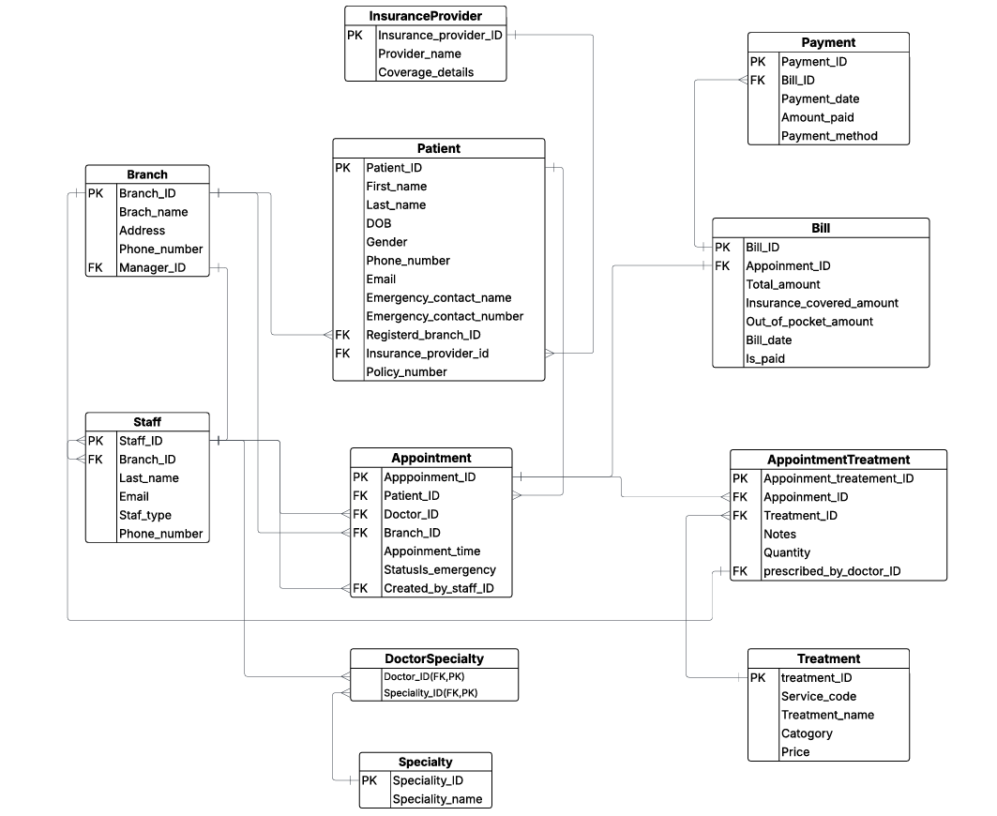

**Use case Diagram**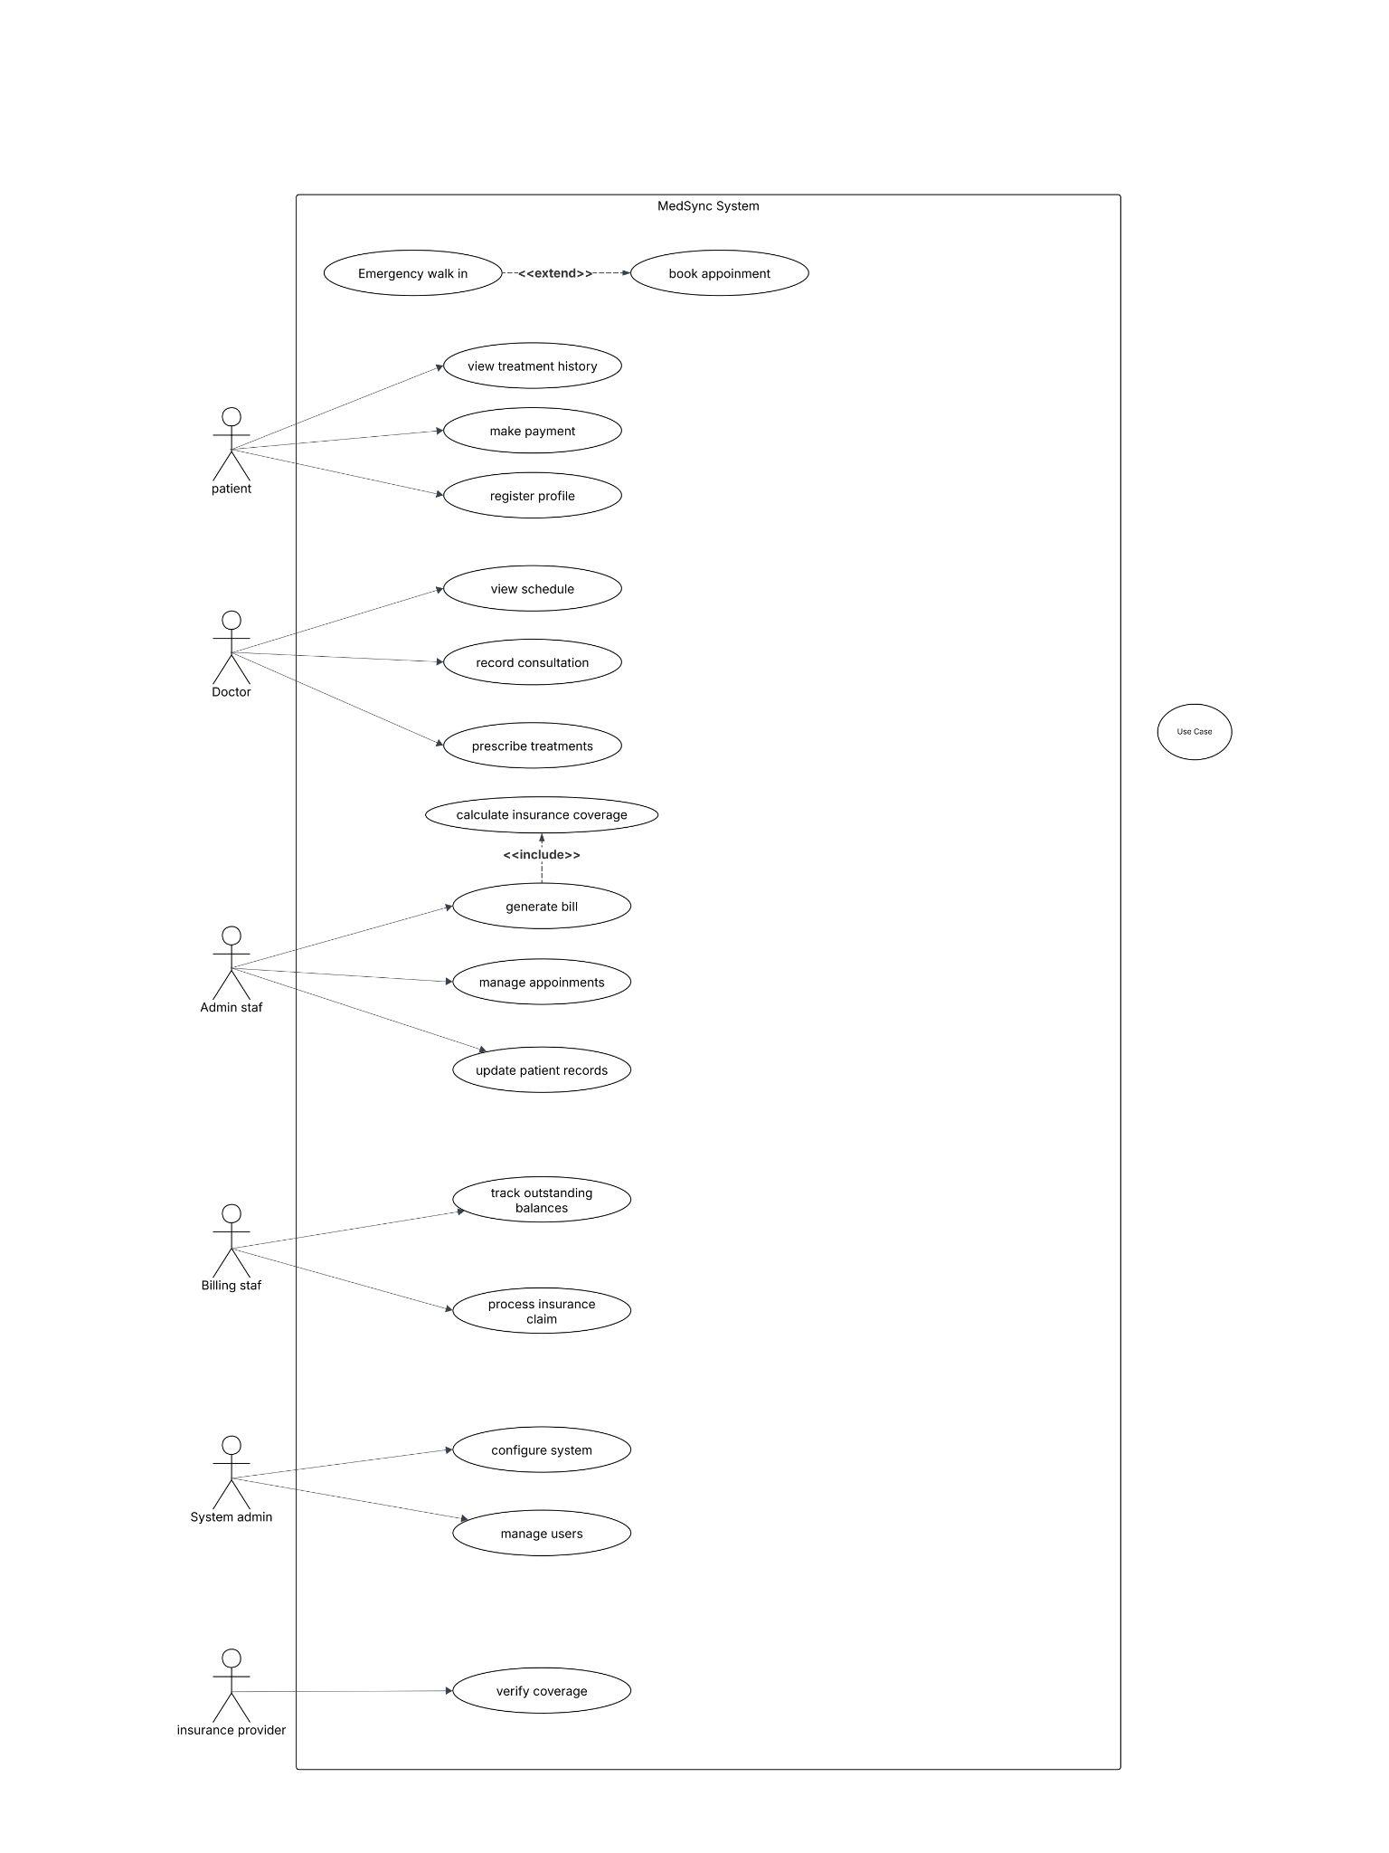

**Appendix C: To Be Determined List**

**1.** **User Interface Design**

* *Specific user interface design elements and layout are yet to be finalized. This includes color schemes, fonts, and overall visual design.*

**2.** **User Documentation Structure**

* *The final structure and content of user manuals and online help resources will be defined as the user interface and system functionality become more concrete.*

**3.** **Additional User Interface Features**

* *We are still thinking about adding extra things to make the system look and feel better. These could be things like making it easier to use, making it look nicer, and adding features that you can click on and interact with.*

**4.** **Future Expansion Plans**

* *The exact plans for future expansions of the system, including the addition of new airports and routes, will be finalized based on market analysis and business needs.*

**5.** **Security Measures**

* *Detailed security measures, including encryption algorithms and access controls, will be determined based on security assessments and best practices.*

**Appendix D: Team members**

| **Index number** | **Name** |
| --- | --- |
| 230139N | DHANAPALA D.H.N |
| 230304R | JEGARASHAN B. |
| 230389E | MALAVIPATHIRANA H.H |
| 230429E | NETHMINA L.T.H |
| 230736R | WITHANAGE M.H |
|  |  |